**DR. G.Y PATHRIKAR COLLEGE OF COMPUTER SCIENCE &**

**INFORMATION TECHNOLOGY, MGM UNIVERSITY**

Mini project

On

GOOGLE ANALYTICS FOR MACHINE LEARNING

*SUBMITTED BY*

***SAUDAGAR MOHAMMAD SHIBAAN***

*Guided by*

***DR. BHARAT R. NAIKNAWARE***

Integrated Bsc-Msc Data Science Fourth Semester,

Academic year 2022-2023

|  |
| --- |
| DR. G.Y PATHRIKAR COLLEGE OF COMPUTER SCIENCE AND INFORMATION TECHNOLOGY, MGM UNIVERSITY  Certificate  This is to certify that, SAUDAGAR MOHAMMAD SHIBAAN has successfully completed the Mini Project Report on **“GOOGLE ANALYTIC FOR MACHINE LEARNING”** for partial fulfillment of the Program Integrated Bsc-Msc Data Science fourth Semester, of MGM University, Dr. G.Y. Pathrikar College of Computer Science and Information Technology, Aurangabad, during the Academic Year 2022-2023.  **Seat No : F0222006**  Dr. Bharat R. naiknaware Dr. Satish Sankaye  **Project Guide Head of the Department**      **Examiner** |

**INDEX**

|  |  |  |
| --- | --- | --- |
| **Sr No.** | **Contents** | **Page No.** |
|  | Abstract | 1 |
| 1 | Introduction  Existing System  Need and Significance of Proposed System | 2 |
| 2 | Motivation | 3 |
| 3 | Scope and Objectives | 4 |
| 4 | Proposed Methodology | 5 |
| 5 | Experiential Result and Result Analysis | 6-15 |
| 6 | Hardware and Software Requirement | 16 |
| 7 | Conclusion | 17 |
| 8 | References | 17 |

**Abstract**

The study is focus on the Analytical report made with the help of Google Analytics of the Real time data of the blog “saudagarshibaan.blogspot.com” as keyword as “Machine Learning”.

These Report represent the Analytics of the Particular pages which are available in the blog. It Analyses the report regarding the viewers of the blog, likes / dislikes of the blog, organic and inorganic viewers, from where the blog has been read out and so on.

The purpose of making the Analytical report of the blog to have the study of the particular blog with the graphical representation of the ups and down of the blog, develop the business form it and have the growth of the blog as well as business.

Google Analytics is a powerful web analytics tool that allows website owners and marketers to track and analyze their website traffic and user behavior. With Google Analytics, users can measure the performance of their website, track user interactions and behavior, and gain insights into how their website is being used. The tool provides a wealth of information, including data on the number of visitors, pageviews, bounce rates, conversion rates, and more. Users can also create custom reports and dashboards to monitor specific metrics and track progress over time. Overall, Google Analytics is an essential tool for any website owner or marketer looking to optimize their website and improve their online presence

Google Analytics also provides a range of reporting and visualization tools, including dashboards, custom reports, and data visualizations. These tools make it easy for website owners to analyze and interpret their data, and to share their insights with stakeholders.

1

**Introduction**

Google Analytics is a web analytical service offered by Google that track ad reports website traffic, currently as a platform inside the Google Marketing Platform brand. Google launched the service in November 2005 after acquiring Urchin.

With the help of the Google Analytical Tool, we have generated reports of our blog regarding with the real time data. The visualization makes understand the influence of blog through the reports and with the help of insights the blog can be modified or updated to the latest need of the modern society.

Google Analytics is a powerful web analytics tool that provides valuable insights into website traffic and user behavior. Developed by Google, it offers a range of features that enable website owners to better understand their audience and make informed decisions about their online presence. With Google Analytics, businesses and organizations can track important metrics such as pageviews, bounce rates, and user demographics, among others, and use this data to optimize their website and marketing strategies. This tool is an essential component of any successful digital marketing strategy, providing valuable insights that help businesses to grow and thrive online. In this era of rapidly-evolving technology, Google Analytics remains a cornerstone of web analytics and a critical tool for any website owner looking to succeed in the online marketplace.

This powerful tool can help businesses and organizations better understand their audience and optimize their online presence for maximum engagement and conversions. With Google Analytics, users can track a wide range of metrics, including pageviews, bounce rates, session duration, and user demographics, among others. This information can be used to identify areas for improvement and to tailor marketing and content strategies to the needs and preferences of the target audience. Google Analytics is an essential tool for any business or organization looking to succeed in the digital age.

Google Analytics is a web analytics tool developed by Google that provides website owners with insights into their website traffic and user behavior. This powerful tool can help businesses and organizations better understand their audience and optimize their online presence for maximum engagement and conversions. With Google Analytics, users can track a wide range of metrics, including pageviews, bounce rates, session duration, and user demographics, among others. This information can be used to identify areas for improvement and to tailor marketing and content strategies to the needs and preferences of the target audience. Google Analytics is an essential tool for any business or organization looking to succeed in the digital age.

2

**Motivation**

There are n number of peoples in society who does not have the knowledge of the field of Data Science. As the modern technology are increasing day-by-day the data is been increasing with the boost speed. So to manage that data the need of Data Science field is in demand in industries. So to reach the correct information or the correct guidance to the society who are having interest towards the field or doesn’t know about the field can have the exact knowledge and the way to proceed towards the Data Science field and have the future in the field of Data Science.

There are many motivations for pursuing a career in data science. Here are a few possible reasons why someone might be drawn to this field:

1. The opportunity to solve complex problems: Data science involves working with large and complex data sets to extract insights and solve problems. For those who enjoy challenging puzzles and intellectual problem-solving, data science can be an incredibly rewarding field.
2. The demand for data scientists: With the explosion of data in recent years, there is a huge demand for skilled data scientists who can make sense of this information. This means that data scientists are in high demand and can often command high salaries.
3. The opportunity to work with cutting-edge technology: Data science involves working with a variety of tools and technologies, including machine learning algorithms, data visualization tools, and cloud computing platforms. For those who enjoy working with the latest technology, data science can be a very exciting field.
4. The opportunity to work in a variety of industries: Data science is applicable to a wide range of industries, from healthcare to finance to retail. This means that data scientists have the opportunity to work in a variety of fields and apply their skills to different problems and challenges.

in summary, data science can be a rewarding and exciting field with many opportunities for impact, growth, and innovation. If you enjoy problem-solving, working with data, and making a difference, then data science may be the perfect career path for you.

3

**Scope and Objectives**

The scope and objectives of using Google Analytics for a blog would typically include the following:

Scope:

* Track the traffic and user behavior on your blog, such as the number of visitors, their location, how long they stay on your site, which pages they visit, etc.
* Monitor the sources of traffic to your blog, such as search engines, social media platforms, or referral sites.
* Analyze the effectiveness of your content, including which blog posts are the most popular, how much time users spend reading them, and what types of content perform best.
* Evaluate the performance of your marketing campaigns, including email marketing or social media advertising, and measure their impact on your blog traffic.
* Identify areas for improvement, such as the user experience, content strategy, or search engine optimization (SEO).

Objectives:

* Increase the number of visitors to your blog, and ultimately, drive more conversions or sales.
* Improve the engagement and retention of your readers by providing valuable and relevant content.
* Optimize the user experience of your blog, such as site speed, navigation, or mobile responsiveness.
* Enhance the visibility of your blog on search engines, such as Google, by improving your SEO efforts.

Overall, the scope and objectives of using Google Analytics for a blog are to help you better understand your audience and optimize your content and marketing strategy to achieve your business goals.

4

**Tools and Technique**

For making of these projects, I have used the Google Analytics Tools. Google Analytics Tools is used globally for the easy analytics of the data which are collected from the website. It’s mainly works on the real-time data and show the updated report.

1. Dashboard: Google Analytics provides customizable dashboards that allow you to monitor the key metrics and KPIs of your website or blog at a glance.
2. Goals: Goals are specific actions that you want your website visitors to take, such as filling out a form, making a purchase, or subscribing to a newsletter. You can set up goals in Google Analytics to measure how well your website is performing against these objectives.
3. Events: Events allow you to track user interactions with your website that do not involve pageviews, such as clicks on a button, downloads of a file, or video plays.
4. Segmentation: Segmentation allows you to group your website visitors based on specific criteria, such as their location, device type, or behavior. This helps you understand your audience better and tailor your content and marketing efforts accordingly.

Overall, these tools and techniques can help you gain deeper insights into your website visitors, track your performance against your business goals, and optimize your content and marketing strategy for better results.

5

**BLOG**

1. **Introduction to machine learning**



1. **how pros and cons of ML impact on enviorment**

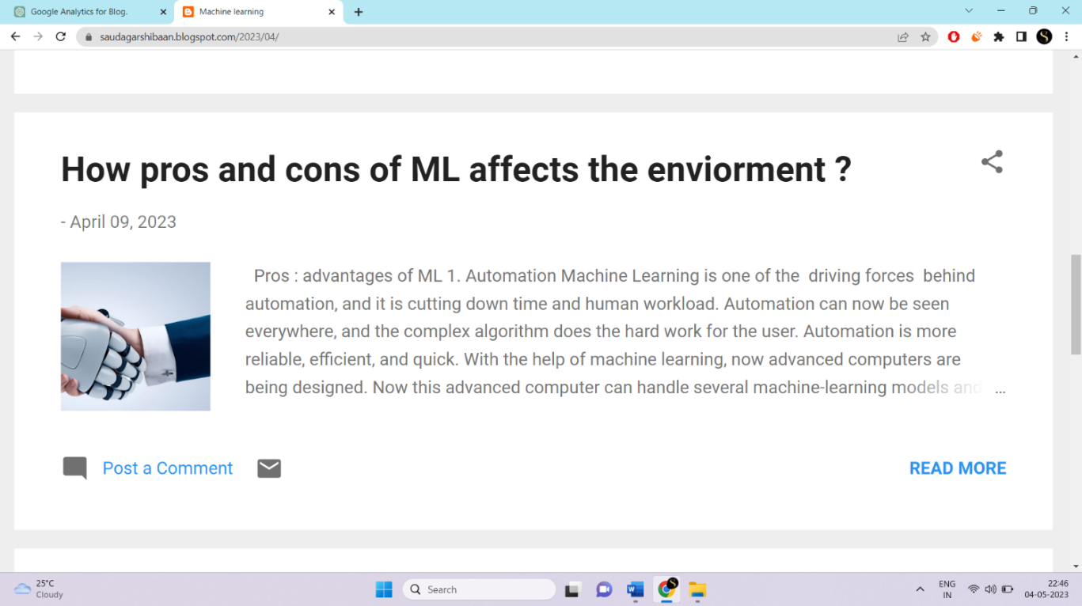

6

1. **which skill required to become ML expert ?**



1. **which are different kind of job opportunaties after upskilled in ML ?**



7

1. **Where do machine learning can be applied ?**



1. **which product based companies are hiring ML experts ?**

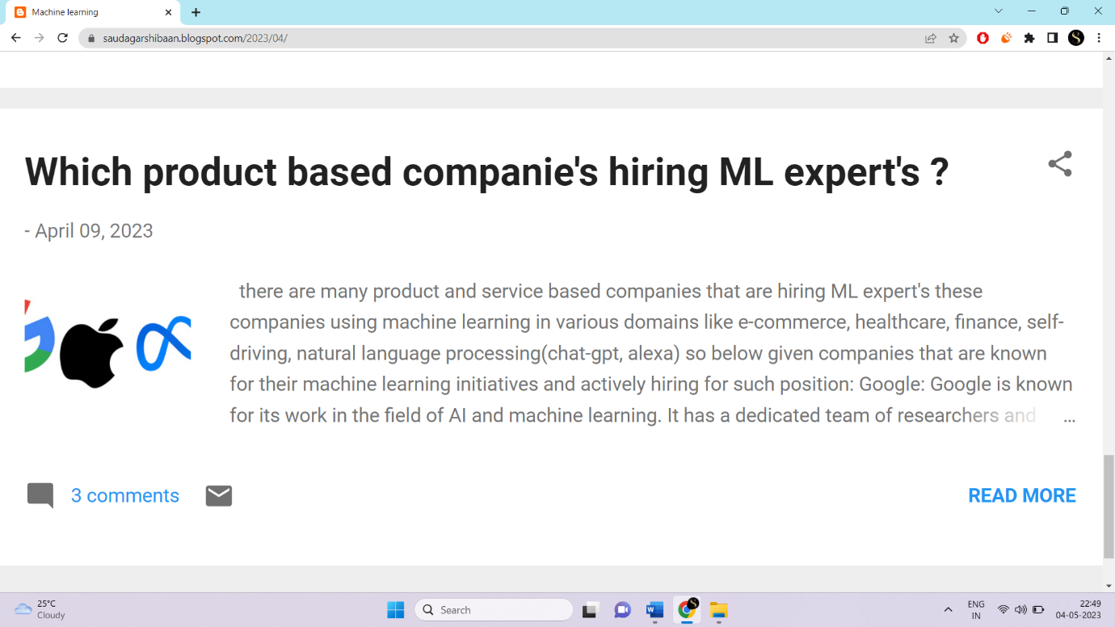

8

**Tracking code**

**<!-- Google tag (gtag.js) -->**

**<script async src="https://www.googletagmanager.com/gtag/js?**

**id=G-RLVHJV261X"></script> <script>**

**window.dataLayer = window.dataLayer || [];**

**function gtag(){dataLayer.push(arguments);}**

**gtag('js', new Date());**

**gtag('config', 'G-RLVHJV261X');**

**</script**

**REPORTS**

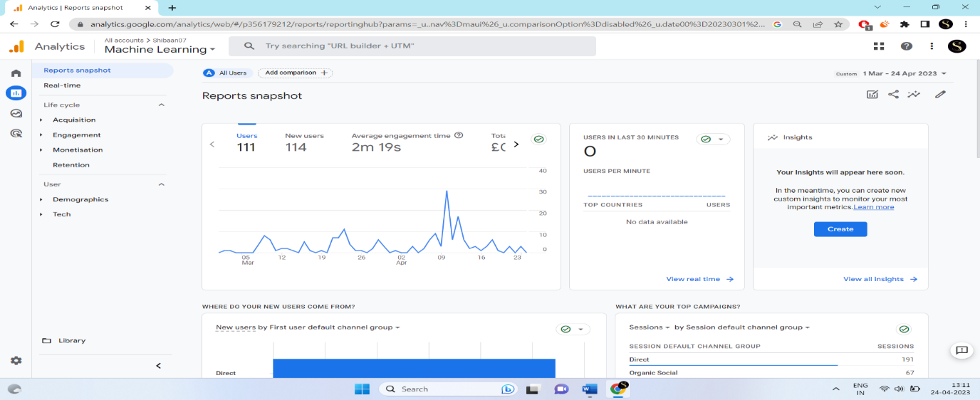

9

**overview**

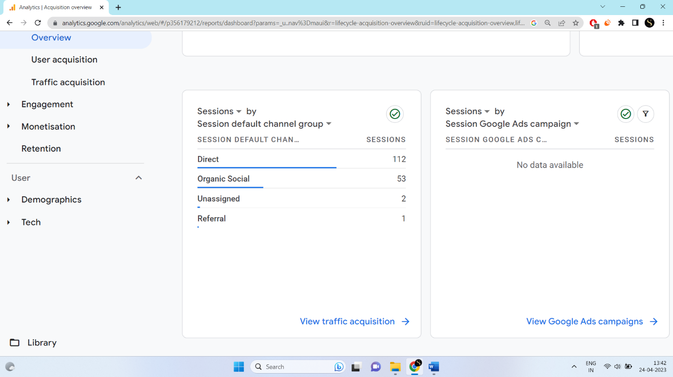

User acquisition

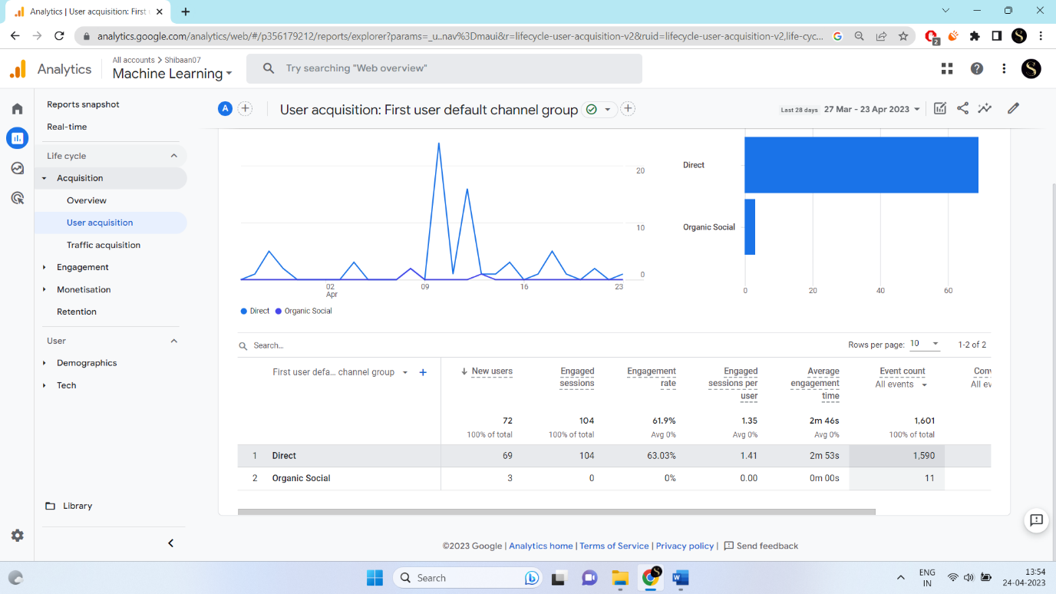

10

Traffic aquasition

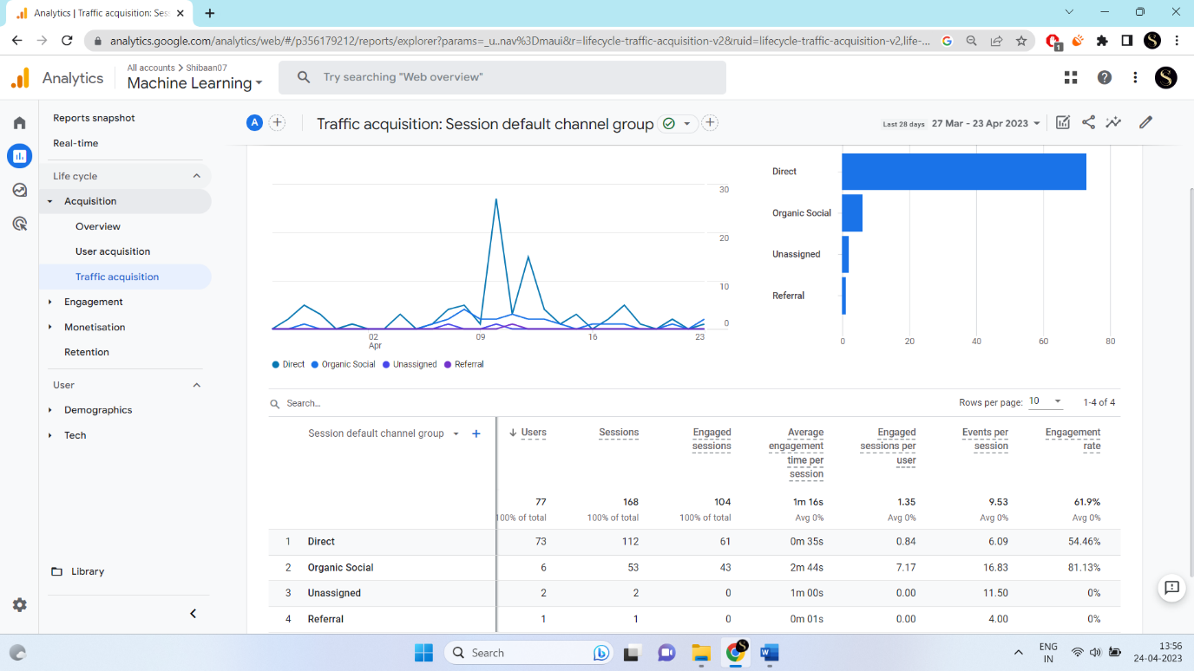

**Engagment**

Overview

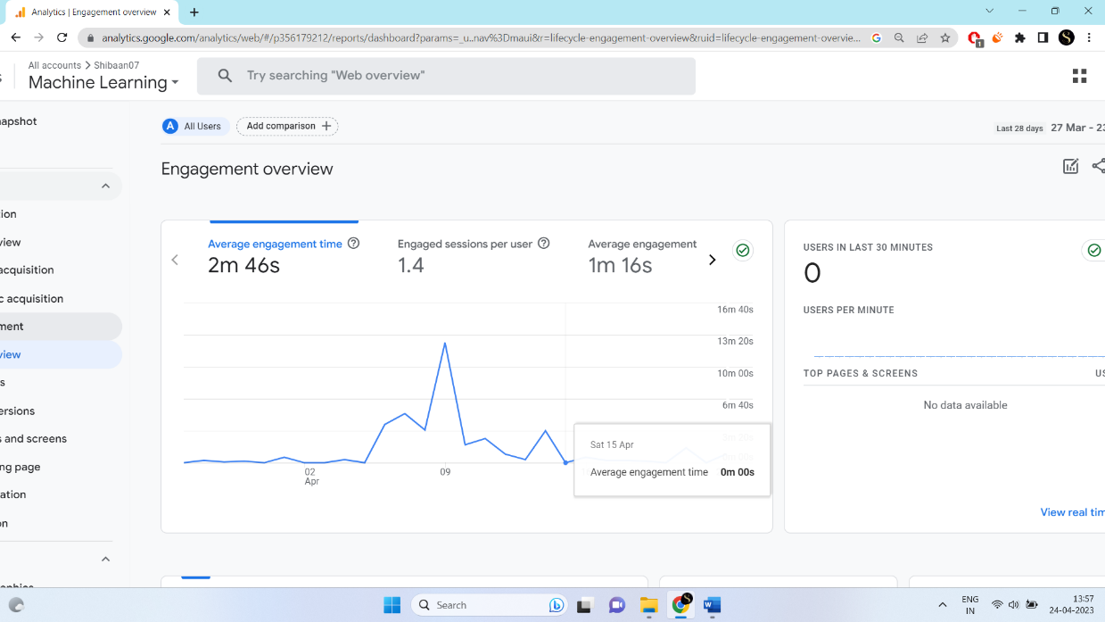

11

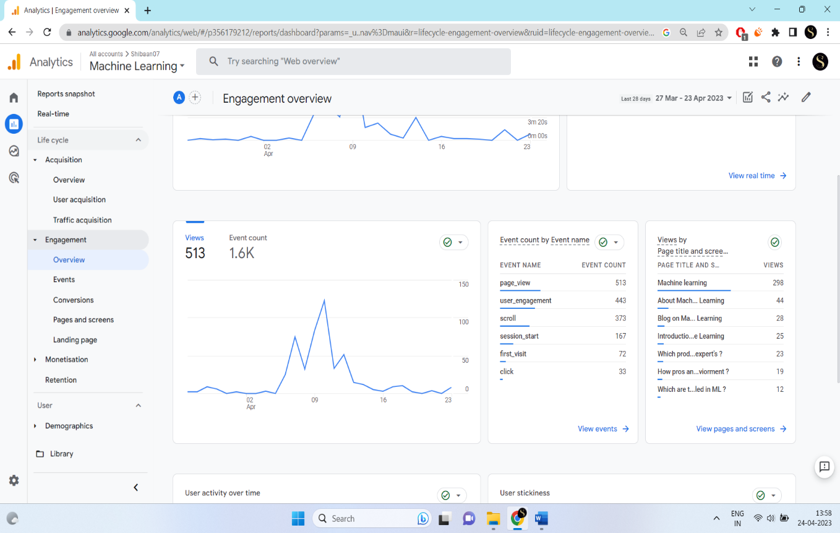

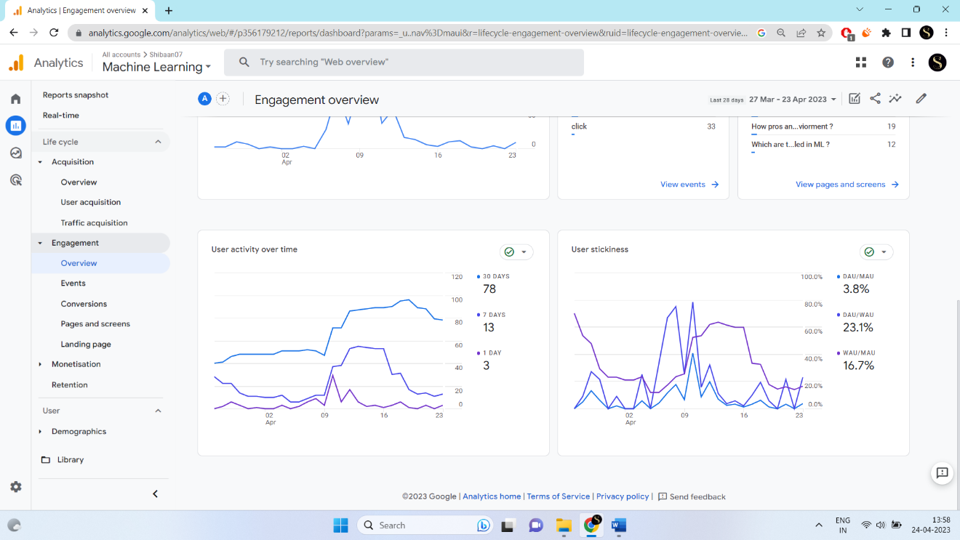

12

Event

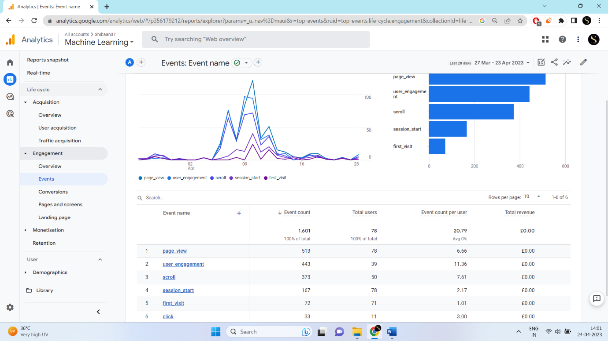

Page and screen

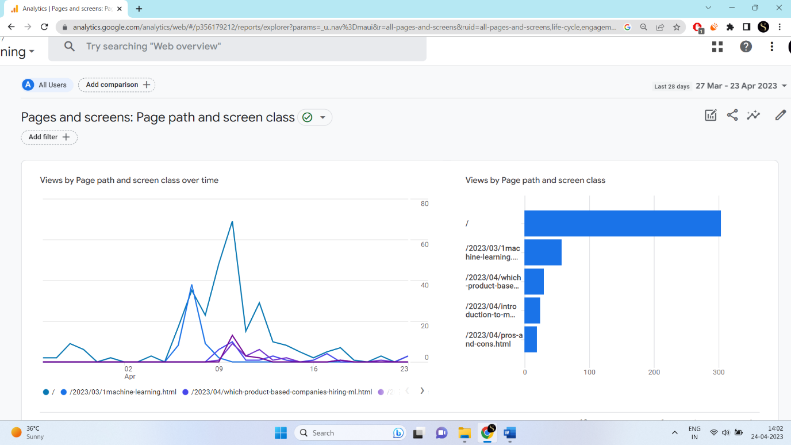

13

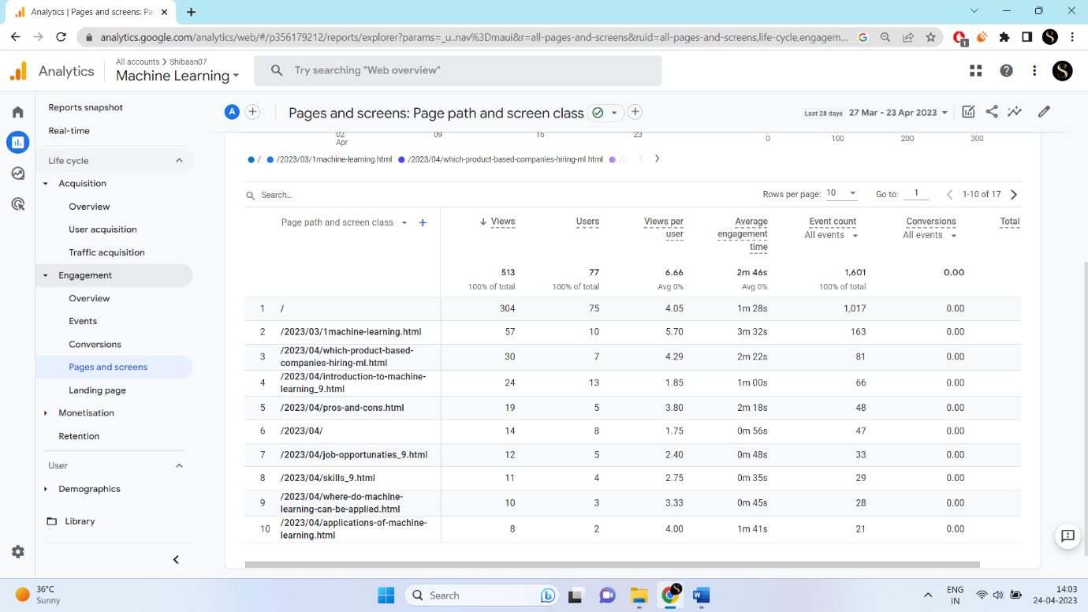

Landing page

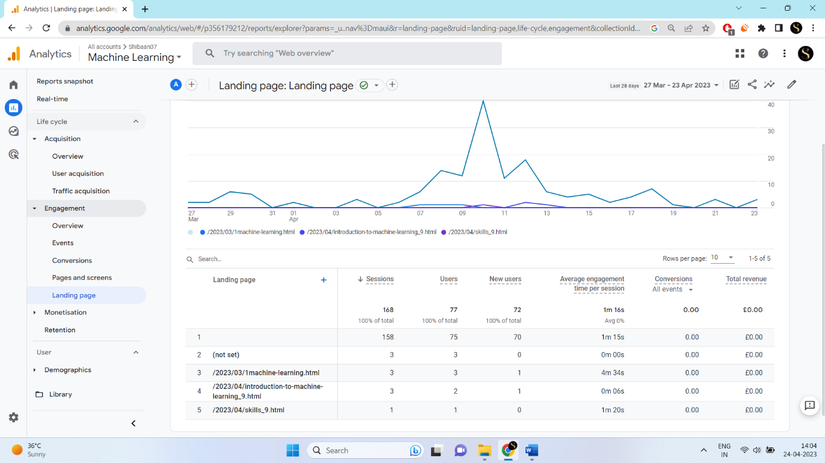

14

**DEMOGRAPHIC**

Overview

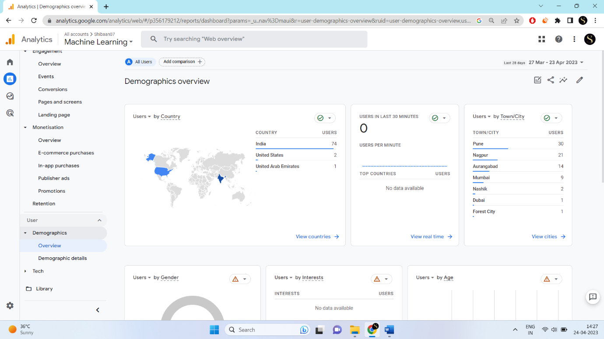

15

**Hardware and software requirement**

**Hardware:**

* Laptop

Device name LAPTOP-4G1N80UD

Processor AMD Ryzen 5 5600H with Radeon Graphics 3.30 GHz

Installed RAM 8.00 GB (7.34 GB usable)

Device ID A9161311-2A29-4078-A2CF-7F48C7D9A79F

Product ID 00356-24604-81977-AAOEM

System type 64-bit operating system, x64-based processor

Pen and touch No pen or touch input is available for this display

**Software:**

* Microsoft Word 365
* Microsoft Edge
* Google

**Conclusion:**

In conclusion, using Google Analytics can provide valuable insights into website traffic and user behavior. By analyzing the data collected through Google Analytics, website owners can make informed decisions about their website's content, design, and marketing strategies. Additionally, Google Analytics can help businesses track the effectiveness of their advertising campaigns and identify areas for improvement. However, it's important to ensure that proper data privacy and security measures are in place when using Google Analytics to collect user data.

Overall, Google Analytics is a powerful tool that can help website owners optimize their online presence and improve their business outcomes.

16

forbusinesses of all sizes to better understand their online presence and make informed decisions

using Google Analytics can provide valuable insights into website traffic, user behavior, and conversion rates. It allows website owners to track the success of their marketing campaigns, optimize their website for better user experience, and make data-driven decisions to improve their business performance. However, it is important to comply with data privacy regulations and ensure that the data collected is used ethically and responsibly. Overall, Google Analytics can be a powerful tool

**Reference**

1. https://www.javatpoint.com/applications-of-machine-learning
2. tutorial’s point
3. https://www.geeksforgeeks.org/7-skills-needed-to-become-a-machine-learning-engineer/
4. https://www.upgrad.com/blog/career-in-data-science/
5. <https://www.simplilearn.com/advantages-and-disadvantages-of-artificial-intelligence-article>

17